Assignment #3, Tree barrier implementation using PThread mutex and conditional variables
Due 11:55PM 03/03, Friday

In this assignment, you will implement a tree barrier to improve the scalability of barrier operations among large number of threads. Skeleton of the code is provided and you should modify the mylib_barrier_t struct and implement the mylib_treebarrier function. A barrier operation is split into two parts (arrival and departure, or gather and signal), as shown in the following figure. Max 4 threads are allowed to form a group in a barrier (the fan-in and fan-out parameter) in any level of the tree barrier hierarchy.

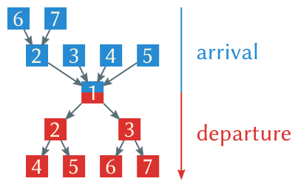

Your submission should include the source code implementation and testing to compare against flat barrier performance.

